CEPOL ORGANISED REGIONAL MOCK TRIAL COURSE IN SERBIA

You are here

[Home](https://www.cepol.europa.eu/) » [Media](https://www.cepol.europa.eu/media) » [News](https://www.cepol.europa.eu/media/news) » CEPOL organised regional mock trial course in Serbia

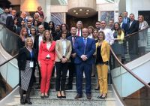

24 October 2019

**CEPOL Financial Investigation In-Service Training Project is implementing regional training course “Mock trial I” in Belgrade, Serbia between 21-25th October 2019.**

The course is organised by the European Union Agency for Law Enforcement Training (CEPOL) within the framework of the capacity-building project Financial Investigation In-Service Training Western Balkan 2017-2019. The Project aims to develop and sustain institutional capacity of the law enforcement agencies of the beneficiary countries (Albania, Bosnia & Herzegovina, Kosovo*, Montenegro, The Republic of North Macedonia and Serbia) in order to prevent, investigate and prosecute transnational organised crime and financing terrorism.

For the first time CEPOL FI Project is implementing Mock trial training and participants are actively taking part in tailor-made workshops during which they are conducting financial investigation and building a case file around a criminal investigation of serious crime case and money laundering. On the last day of training participants will take part in simulation of a criminal court trial. The course brought together 33 law enforcement officials, prosecutors and judges from Bosnia and Herzegovina, Montenegro and Serbia.

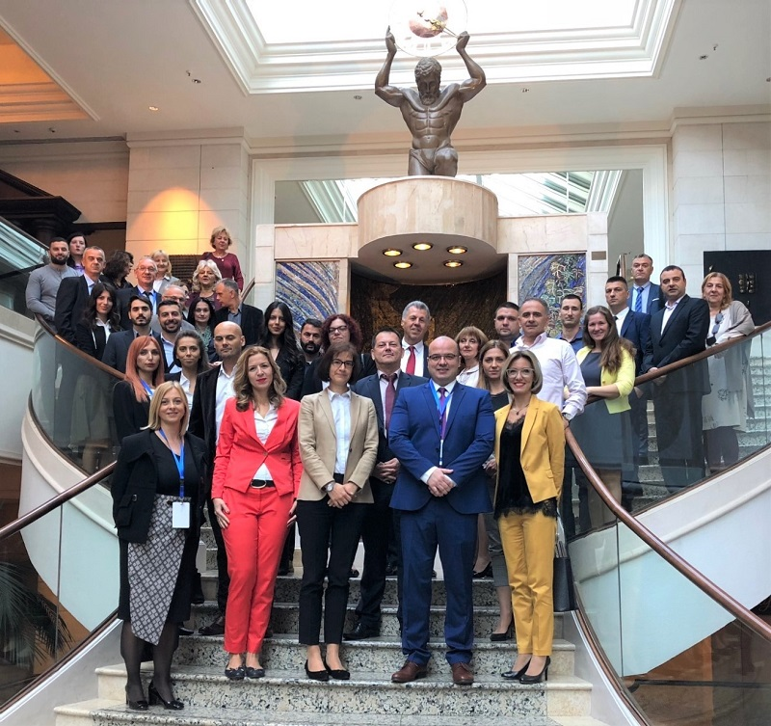

The objectives of the training are:

1. To identify and enhance knowledge about tools and techniques of Financial Investigations
2. To introduce best practices in the EU for the investigation and adjudication of money laundering
3. To improve investigation, cooperation and trial skills
4. To create sustainable professional networks and strengthen multidisciplinary cooperation between law enforcement

The next training activity within the Western Balkans Financial Investigation In-Service Training Project ***‘Financial investigations related to corruption’*** **takes place in Skopje, North Macedonia from 4 to 8 November 2019.**

The Project is funded by the European Commission under the Instrument for Pre-Accession Assistance (IPAII) and it is an integral part of the second IISG Pillar (WBCSCi).